***CULTURE & ARCHEOLOGY TOURS***

Positioned in the western reaches of the Indian subcontinent, Pakistan has served as a gateway to the fertile plains of India since ancient times. Its lands have absorbed migrations, invasions, and cultural mergers, intricately weaving its historical narrative. From Aryan movements to northward nomadic influxes and Persian conquests, the region’s story is a tapestry of diverse influences. Alexander the Great’s momentous campaign marked a turning point, initiating a series of invasions that imprinted distinctive cultures on the land. Despite the Mongol devastation, their successors established the influential Mughal dynasty, etching a legacy in Pakistan’s history. A harmonious medley of cultures emerges, with each province resonating unique traditions. As the cradle of the Indus Valley civilization, dating back to 2500 BCE, Pakistan cherishes its archaeological treasures along the Indus River. Ongoing western influences add layers to its cultural mosaic, including the enduring legacy of the Gandhara culture, visible even in western Chinese cities. Pakistan’s allure lies in its rich historical chronicles and diverse cultural heritage, inviting explorers to unravel the intricate interplay of human civilizations across time.

Tour Itinerary

**Day 01:**  
**Arrival – Lahore Sightseeing**

Upon arrival at Lahore airport, you will be transferred to your hotel in Lahore. Begin your exploration by visiting the magnificent Lahore Fort, a masterpiece of Mughal architecture, and admire the enchanting Shish Mahal within its premises. Experience the grandeur of the Badshahi Mosque, one of the world’s largest historical mosques, known for its architectural splendor. Immerse yourself in the vibrant atmosphere of Lahore’s old city, with its captivating blend of history and culture. Later, embark on a journey to the Wagah Border, where you will witness an impressive ceremony between the two countries, characterized by a handshake and a spectacular martial display. This unique experience will leave an indelible impression on your memory. Overnight Lahore.

**Day 02:**  
**Lahore Sightseeing**

Begin your day by exploring the enchanting Shalimar Garden, a symbol of love and happiness, featuring triple terraced gardens adorned with marvelous marble pavilions. This Persian-style garden, commissioned by Emperor Shah Jahan, is considered one of the world’s finest. Next, visit the splendid Emperor Jahangir’s Tomb, showcasing breathtaking mosaics and intricate inlay work. The tomb, surrounded by serene symmetrical gardens, pays homage to the fourth Mughal emperor. Immerse yourself in the rich cultural and historical heritage of the region at the Lahore Museum, where rare manuscript miniatures and Islamic calligraphy are on display, providing a comprehensive glimpse into the region’s culture and history. Overnight Islamabad.

**[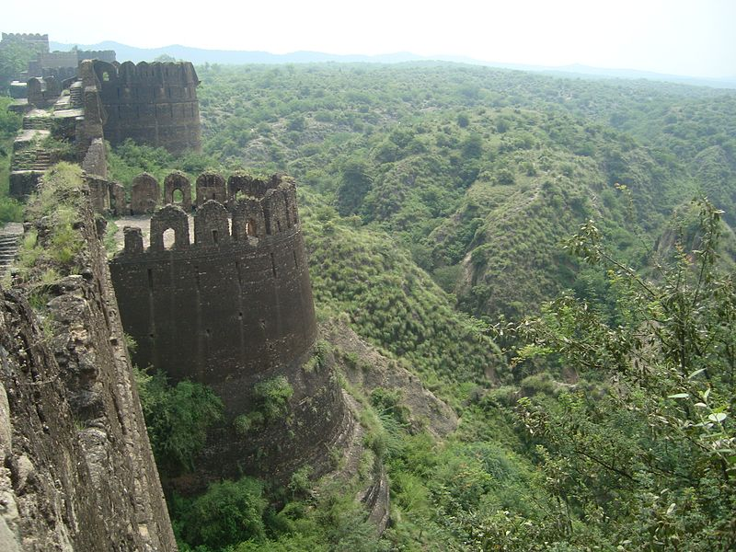](https://www.pakistantours.pk/wp-content/uploads/2023/09/Rohtas-fort.jpg)Day 03:  
Lahore – Rohtas Fort – Islamabad**

Starting our journey from Lahore to Islamabad, we follow the historic Grand Trunk Road, which has its roots in the reign of Chandragupta Maurya in the 3rd century BCE. This road, reinforced during British rule, served as a vital trade route connecting the Ganges River to Kabul. Along the way, we encounter remnants of the Mughal era, such as the tamarisk trees planted by the Mughals. Our first stop is the magnificent Rohtas Fort, a testament to the region’s architectural splendor. Here, we enjoy a picnic lunch amidst the fort’s impressive surroundings. Passing through the Potohar plateau, known for its unique Soan Valley culture, we finally arrive in Islamabad, the capital city, in the late afternoon, concluding a day filled with historical exploration and natural beauty. Overnight Islamabad.

**Day 04:**  
**Islamabad Sightseeing**

Embarking on a sightseeing tour of Islamabad, we first visit Shakarparian Hills, where we admire the panoramic view of the modern cityscape and lush green surroundings. Our next stop is the Museum of Folk Heritage, also known as Lok Virsa, where we delve into Pakistan’s rich cultural traditions through folk art, crafts, and music. Driving through important boulevards, we pass significant landmarks including the Diplomatic Enclave, Parliament House, and the Presidential Palace, representing the nation’s administrative and diplomatic centers. The Margalla Hills provide a scenic backdrop as we make a stop at Saidpur model village, immersing ourselves in its nostalgic atmosphere. Our tour culminates at the magnificent Faisal Mosque, a grand architectural masterpiece. In the evening, we enjoy a delightful dinner at a panoramic hilltop, relishing both the cuisine and the breathtaking views of Islamabad’s skyline. This comprehensive tour allows us to appreciate Islamabad’s cultural, architectural, and natural wonders. Overnight Islamabad.

[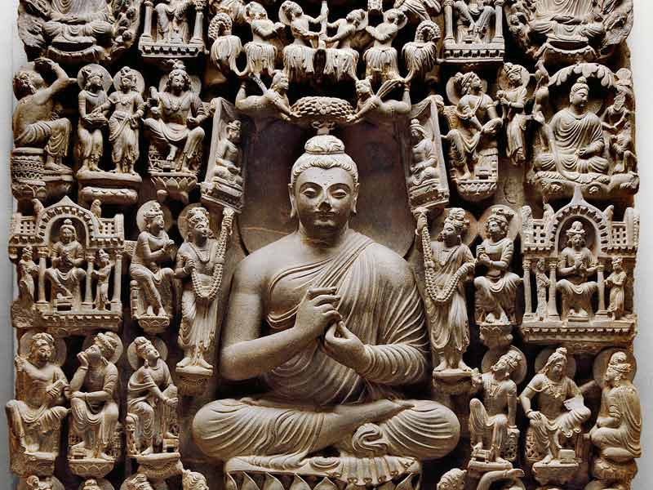](https://www.pakistantours.pk/wp-content/uploads/2023/09/Gandhara.jpg)**Day 05:**  
**Islamabad – Taxila – Peshawar**  
  
Departing from Islamabad, our journey to Peshawar takes us through the ancient city of Taxila, which dates back to the 5th century BC. Taxila’s strategic location as a crossroads between Western and Eastern Asia made it a significant center of trade and culture. We explore the first city of Taxila, discovering remnants and the impressive stupa court of Dharmarajika. Moving on to Sirkap, the second city planned by the Bactrian Greeks, we marvel at its well-organized layout and fascinating structures. The ruins of Jaulian Buddhist monastery atop a hill offer a glimpse into the region’s Buddhist heritage. Before reaching Peshawar, we visit the Archaeological Museum, housing exquisite artifacts from the site. Our journey also includes a stop at the Indus River crossing, offering picturesque views of Akbar the Great’s Attock Fort. This itinerary enables us to immerse ourselves in Taxila’s ancient history, setting the stage for further exploration in the captivating city of Peshawar. Overnight Peshawar.

**Day 06:**  
**Peshawar Sightseeing**

Our full-day sightseeing tour of Peshawar begins with an exploration of its traditional bazaars, starting with the lively Qissa Khawani bazaar known for its storytellers. We continue our walk through the Copper bazaar, Spice Street, cloth market, shoe bazaar, and the vibrant vegetable market, immersing ourselves in the bustling atmosphere and colorful displays. Along the way, we visit the gold market, where we admire the intricate jewelry designs. Our tour also includes a visit to the magnificent Mohabat Khan’s Mosque, a splendid example of Mughal architecture from the 17th century. In the afternoon, we delve into the artistic wonders of the Peshawar Museum, marveling at its impressive collection of Gandharan Art. This comprehensive tour allows us to experience the vibrant bazaars, architectural marvels, and artistic heritage of Peshawar, providing us with a deeper understanding of the city’s rich cultural tapestry. Overnight Peshawar.

**[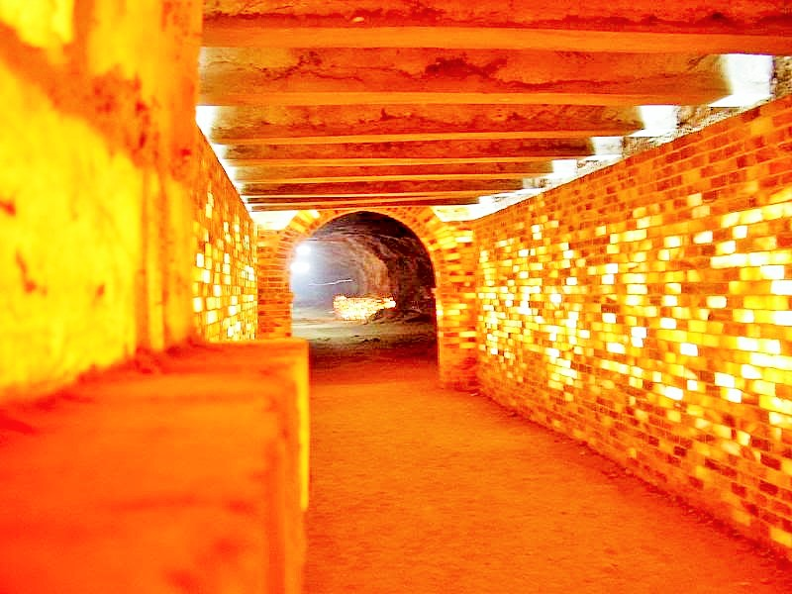](https://www.pakistantours.pk/wp-content/uploads/2018/09/Khewra-Salt-Mines.jpg)Day 07:  
Peshawar – Khewra Salt Mine – Lahore**

During our return journey to Lahore, we have the opportunity to visit the captivating Khewra Salt Mines, nestled in the foothills of the Salt Range. As the second largest salt mine globally, it attracts a significant number of visitors each year. These mines have a rich history dating back to 320 BC when salt was discovered by Alexander the Great’s troops. The Khewra Salt Mines are the oldest in South Asia and were developed further by Dr. Warth in 1872, transforming the main tunnel into a tourist destination. Exploring the underground tunnels allows us to witness the breathtaking salt formations that have been shaped over centuries. The vivid colors and intricate patterns within the mines create a surreal and enchanting ambiance. This visit provides a captivating glimpse into the region’s mining heritage, the significance of salt, and the awe-inspiring natural wonders hidden beneath the surface.

**Discover**Pakistan’s rich heritage and culture through our diverse range of advance reservation tours. From historical and architectural wonders to spiritual and adventurous journeys, we have something for everyone. Explore the enchanting Hunza Valley, follow in the footsteps of legends like Marco Polo, or immerse yourself in the mysticism of Sufi traditions. With options like Heritage & Culture Tours, Karakoram Highway Adventures, and more, unforgettable experiences await. Reserve your spot today and embark on a journey that will create lasting memories.

**Karakoram Highway Tours:** Embark on an exhilarating journey along the Karakoram Highway, witnessing breathtaking landscapes and remote villages.

**Heritage & Culture Tours:** Immerse yourself in the essence of Pakistan’s heritage, visiting historical sites and experiencing its rich cultural tapestry.

**Hunza Valley Tours:** Discover the enchanting beauty of Hunza Valley, surrounded by towering peaks and steeped in local traditions.

**UNESCO Heritage Site Tour:** Unveil the wonders of Pakistan’s UNESCO-listed sites, a testament to its historical and architectural significance.

**Swat Valley Tours:** Explore the picturesque Swat Valley, known for its lush greenery, serene rivers, and historical sites.

**Kalash Valley Tours:** Immerse yourself in the unique culture of the Kalash people, known for their vibrant festivals and distinct way of life.

**Lahore City Tours:** Experience the vibrant heart of Lahore, visiting its historical landmarks, bustling bazaars, and cultural sites.

**Islamabad City Tours:** Discover the modern capital city of Islamabad, known for its well-planned layout and beautiful landscapes.

**Karachi City Tours:** Explore the bustling metropolis of Karachi, a city of diverse cultures, modernity, and historical sites.

**Day Tours:** Enjoy shorter excursions to explore specific sites and attractions within various cities and regions.

**Multi-Day Tours:** Embark on extended journeys that allow you to delve deeper into the diverse regions and cultures of Pakistan.

**Hunza Cherry Blossom Tours:** Witness the stunning spectacle of cherry blossoms in full bloom against the backdrop of the Hunza Valley.

**Hunza Autumn Tours:** Experience the vibrant colors of autumn in Hunza, a season that transforms the landscape into a breathtaking canvas.

**Kaghan Valley Tours:** Discover the natural beauty of Kaghan Valley, with its lush forests, serene lakes, and stunning mountain vistas.

**North Pakistan Tours:** Explore the northern regions of Pakistan, home to some of the world’s highest peaks and captivating landscapes.

**South Pakistan Tours:** Immerse yourself in the rich culture and history of southern Pakistan, from ancient civilizations to coastal wonders.

**South Punjab Tours:** Uncover the hidden gems of South Punjab, experiencing its unique heritage and landscapes.

*Reserve your spot now to embark on an incredible journey of discovery and exploration across Pakistan’s diverse landscapes and cultural treasures.*